Directions: The goal of the following problems is to help challenge and deepen your understanding of the current topic. Don’t assume that you will know how to answer each and every question. You will work with at least two other students in the class to try and find solutions and write arguments for each of the following questions. Be sure that you question your classmates’ reasoning. If you don’t understand how they are getting something you should ASK THEM TO EXPLAIN! Being able to defend your reasoning is important and so you are actually helping them by asking them to explain.
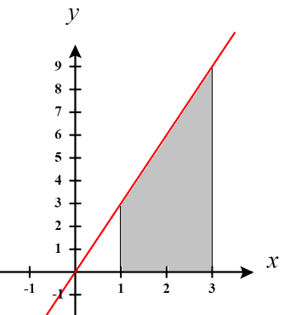
Challenge Questions
- Consider the definite integral .
- Sketch what is graphically represented by this integral.

The integral represents the area between and the x-axis on the interval . This area is shaded in the picture at the right.
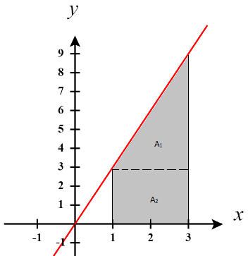
- Use geometry to calculate this integral.

We see that this region can be thought of as a triangle atop a rectangle. We call the area of the triangle and the area of the rectangle . We see that and .
Therefore, we have that .

- Show that this integral equals 12 using the limit definition of the definite integral.

We use the definition of the definite integral to set up the following:
Width of Rectangles | Right Endpoints | Height of Rectangles
Therefore, we can say that . We then calculate:
EXTENSIONS
- Show that this integral equals 12 using the limit definition of the definite integral and where you use left endpoints for your selection of .

We use the definition of the definite integral to set up the following:
Width of Rectangles | Left Endpoints | Height of Rectangles
Therefore, we can say that . We then calculate:

- TRUE or FALSE: If the function is integrable on then it must always produce an integral value of 12 regardless of the selection of the points for .

TRUE. The limit must always result in 12 (regardless of the selection of ) in order to be integrable. If any possible of resulted in a different limit value, then the function would not be considered integrable.

- Based on your answer to the previous part, how could one ever possibly show that a function is NOT integrable?

You would need to find two different selections for that yield two different results for the integral.

- Evaluate the integral using the limit definition of the definite integral.

We use the definition of the definite integral to set up the following:
Width of Rectangles | Right Endpoints | Height of Rectangles
Therefore, we can say that . We then calculate:

- Relate each of the following limits to a definite integral over the specified interval. (Use right endpoints.)
- over .
Since we are working on the interval it must be the case that .
We can then establish that
We then rewrite the given limit as follows:

This leads us to see that and so it must be the case that .

Therefore, we have that
- over .
Since we are working on the interval it must be the case that .
We can then establish that

We then rewrite the given limit as follows:

This leads us to see that and so it must be the case that .

Therefore, we have that

- over .

Since we are working on the interval it must be the case that .
We can then establish that

We then rewrite the given limit as follows:

This leads us to see that and so it must be the case that .

Therefore, we have that

- Consider the integral .
- Construct a limit (whererepresents the right endpoints of our sub-intervals) that is equal to this integral.

We use the definition of the definite integral to set up the following:
Width of Rectangles | Right Endpoints | Height of Rectangles
Therefore, we can say that .
Note that this limit can’t be evaluated using the techniques that we discussed in section 5.2.1 (specifically with the ideas of the values of .

- In the previous questions we were always using as the right endpoint of our intervals. This worked well for these examples, but sometimes it can be easier to use other values. Show how if we choose to be the geometric mean of and (that is, ) then we can find .
Hint: determine some formulas for & and use the identity .

We use the definition of the definite integral to set up the following:
Width of Rectangles | Special value of x | Height of Rectangles

We can easily define and based on this we can say that .
From here we then return to the value of .

From here we attempt to use the identity that we have been given.
Therefore, we can say that

